HIVE ARCHITECTURE IN BREIF
It is a platform used to develop SQL type scripts to do MapReduce operations.

What is Hive
Hive is a data warehouse infrastructure tool to process structured data in Hadoop. It resides on top of Hadoop to summarize Big Data, and makes querying and analyzing easy.
Initially Hive was developed by Facebook, later the Apache Software Foundation took it up and developed it further as an open source under the name Apache Hive. It is used by different companies. For example, Amazon uses it in Amazon Elastic MapReduce.

Hive is not
- A relational database
- A design for OnLine Transaction Processing (OLTP)
- A language for real-time queries and row-level updates

Features of Hive
- It stores schema in a database and processed data into HDFS.
- It is designed for OLAP.
- It provides SQL type language for querying called HiveQL or HQL.
- It is familiar, fast, scalable, and extensible.

Architecture of Hive
The following component diagram depicts the architecture of Hive:
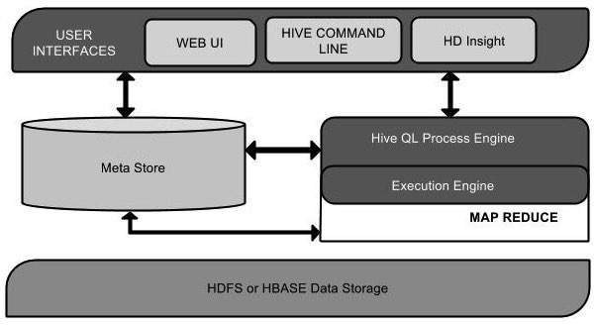
This component diagram contains different units. The following table describes each unit:
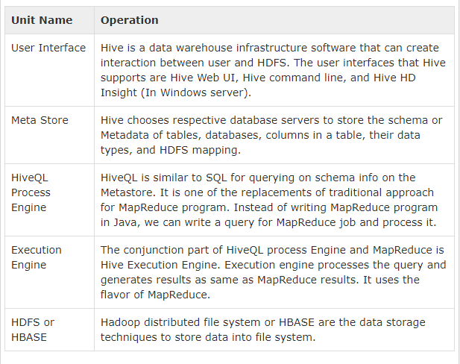

Working of Hive
The following diagram depicts the workflow between Hive and Hadoop.
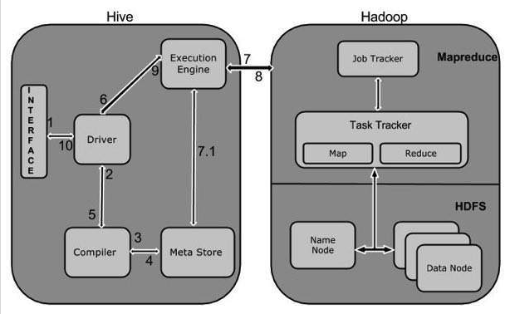
The following table defines how Hive interacts with Hadoop framework:
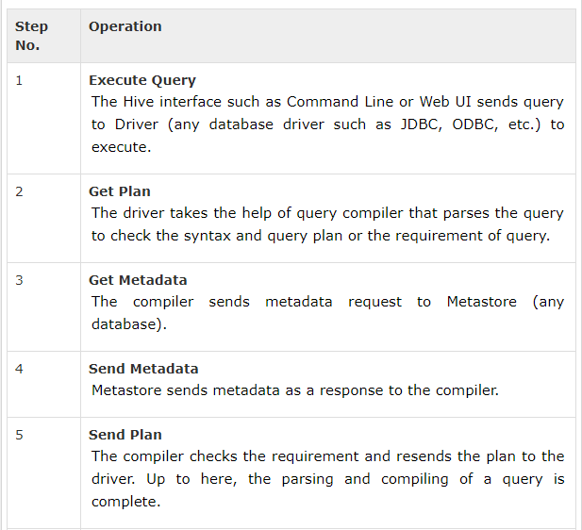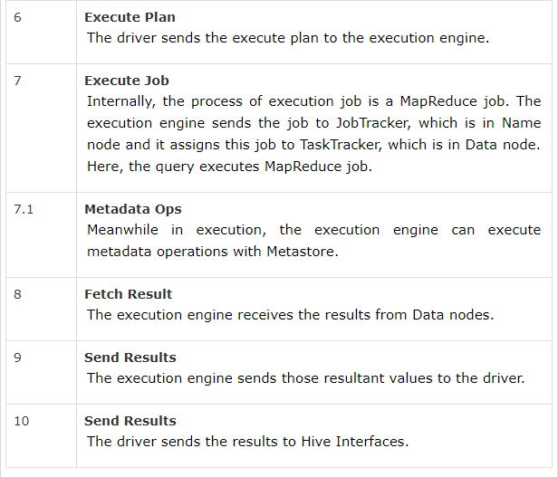
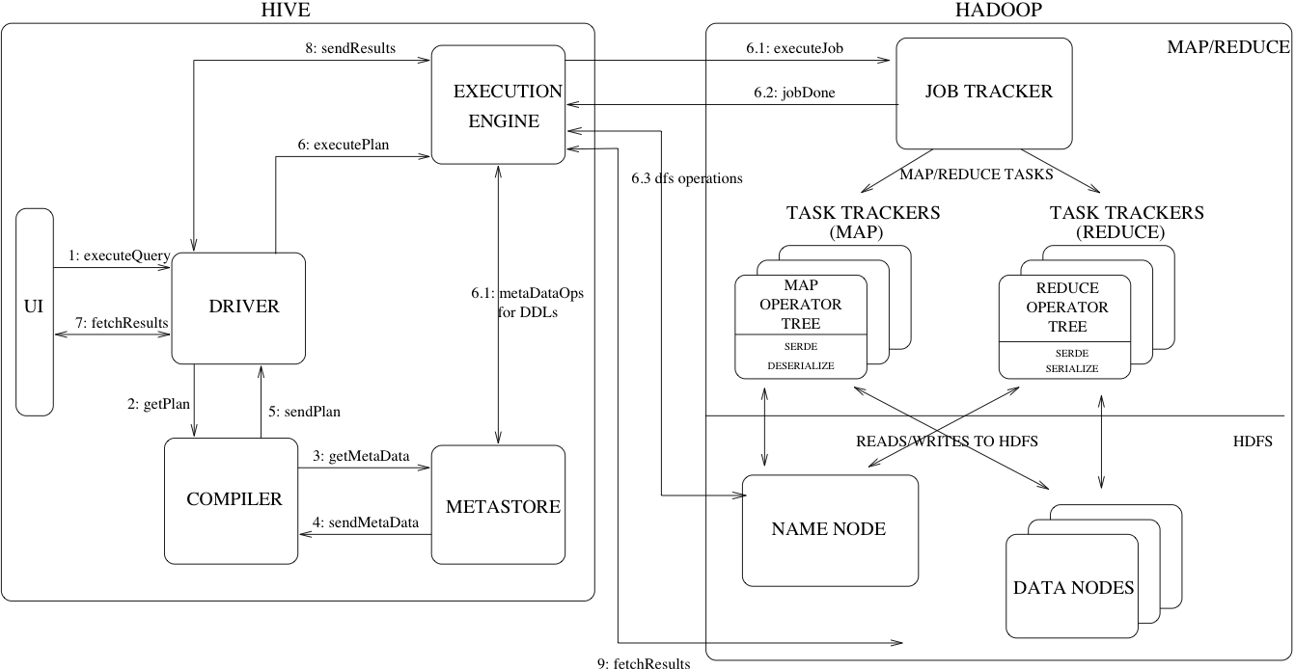
The above diagram shows how a typical query flows through the system
Step 1 :- The UI calls the execute interface to the Driver
Step 2 :- The Driver creates a session handle for the query and sends the query to the compiler to generate an execution plan
Step 3&4 :- The compiler needs the metadata so send a request for getMetaData and receives the sendMetaData request from MetaStore.
Step 5 :- This metadata is used to typecheck the expressions in the query tree as well as to prune partitions based on query predicates. The plan generated by the compiler is a DAG of stages with each stage being either a map/reduce job, a metadata operation or an operation on HDFS. For map/reduce stages, the plan contains map operator trees (operator trees that are executed on the mappers) and a reduce operator tree (for operations that need reducers).
Step 6 :- The execution engine submits these stages to appropriate components (steps 6, 6.1, 6.2 and 6.3). In each task (mapper/reducer) the deserializer associated with the table or intermediate outputs is used to read the rows from HDFS files and these are passed through the associated operator tree.Once the output generate it is written to a temporary HDFS file though the serializer. The temporary files are used to provide the to subsequent map/reduce stages of the plan.For DML operations the final temporary file is moved to the table’s location
Step 7&8&9 :- For queries, the contents of the temporary file are read by the execution engine directly from HDFS as part of the fetch call from the Driver
HIVE COMPONENTS

Major Components of Hive
UI :- UI means User Interface, The user interface for users to submit queries and other operations to the system.
Driver :- The Driver is used for receives the quires from UI .This component implements the notion of session handles and provides execute and fetch APIs modeled on JDBC/ODBC interfaces.
Compiler :- The component that parses the query, does semantic analysis on the different query blocks and query expressions and eventually generates an execution plan with the help of the table and partition metadata looked up from the metastore.
MetaStore :- The component that stores all the structure information of the various tables and partitions in the warehouse including column and column type information, the serializers and deserializers necessary to read and write data and the corresponding HDFS files where the data is stored.
Execution Engine :- The component which executes the execution plan created by the compiler. The plan is a DAG of stages. The execution engine manages the dependencies between these different stages of the plan and executes these stages on the appropriate system components.
Major Components of Hive and its interaction with Hadoop:
Hive provides external interfaces like command line (CLI) and web UI, and application programming interfaces (API) like JDBC and ODBC
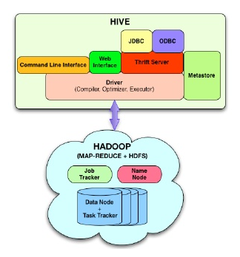
The Hive Thrift Server exposes a very simple client API to execute HiveQL statements. Thrift is a framework for cross-language services, where a server written in one language (like Java) can also support clients in other languages.
The Metastore is the system catalog. All other components of Hive interact with the Metastore.
The Driver manages the life cycle of a HiveQL statement during compilation, optimization and execution.
The Compiler is invoked by the driver upon receiving a HiveQL statement. The compiler translates this statement into a plan which consists of a DAG of map/reduce jobs.
The driver submits the individual map/reduce jobs from the DAG to the Execution Engine in a topological order. Hive currently uses Hadoop as its execution engine.

